Faculty’s Profile – Uttam Nath
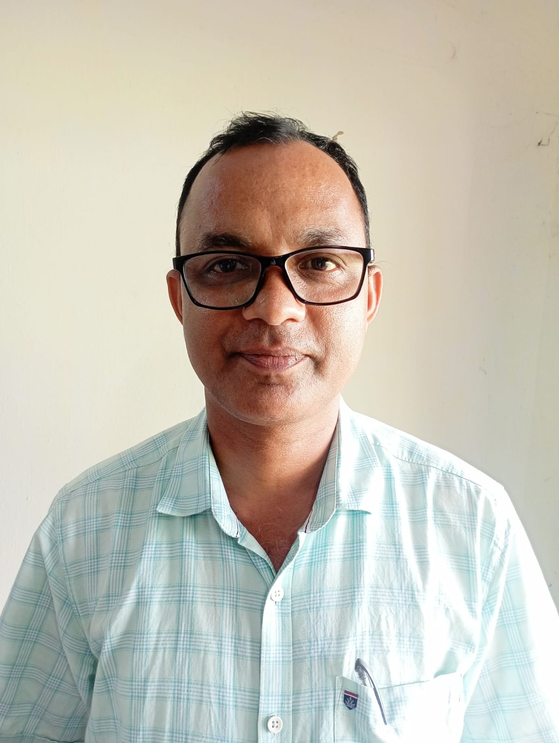
- Personal Information:
- Name : Mr. Uttam Nath
- Designation : Assistant Professor
- Department : Sociology
- Date of Birth : 03/01/1977 :
- Date of joining : 28/08/2003
- Nationality : Indian
- Contact Details:
- E-mail Id : uttamnathh1977@gmail.
- Phone number : 8134077723
- Address : Hazari Gaon Jorhat, Assam PIN:785701
- About Me (Biography) : Blood Group- B⁺, Height: 5 ft 5 inch
Identification Mark: A black mole over back side of body

- Areas of specialization/ interest:
i) Economic Development
ii) Rural Sociology
iii) Industrial Sociology, Sociology of North east India

- Educational qualifications
- Education:
Exam. | Subject | Board/University | Year of Passing
Post-Graduation | Sociology | Dibrugarh University | 2003
Graduation | Sociology | Dibrugarh University | 2000
H. S. | Eng, Ass, Soc, Edn, Eco. Psc, | AHSEC | 1995
H. S. L. C. | Eng. Ass. Math. G.Sc. Soc. Studies. Hindi | SEBA | 1993

- Teaching Experience:
- Teaching Experience (within organization)
Name of the Institution | Designation | Organization Unit | Duration | Status
Dr. Nobin Bordoloi College | Asst. Professor | Govt. | 22 years | Continuing

- Administrative Experience:
- Administrative Experience within organization:
Institution | Designation | Assignment | Duration | Remarks | Status
Dr. Nobin Bordoloi College | HoD of Sociology |  | 3 year |  | Changed

- Teaching Activities:
- Teaching: EVEN SEMESTER
Semester | Course Title | Activity Type | Credit
BA 1st Major | Introduction to Sociology-I- | Lectures & Tutorials | 4-
BA 1st Minor | Sociological Perspectives | Do | 4
BA 1st GEC | Introduction to Sociology | Do | 3
BA 2nd Major | Introduction to Sociology-II | Do | 4
BA 2nd Minor | Sociology of India | Do | 4
BA 2nd GEC | Indian Society: Reality and Images | Do | 3
BA 3rd Major | Sociology of India-I | Do- | -4
BA 3rd Minor | Methods of Sociological Enquiry | Do | 4
BA 3rd GEC | Marriage, Family and Kinship | Do | 3
BA 4th Major | Sociological Research Methods-I | Do | 4
BA 4th Minor | Economy and Society | Do | 4
BA 5th Major | Sociology of Kinship- | Do- | -4
BA 5th Major | Political Sociology | Do | 4
BA 5th Major | Sociological Research Methods-II | Do | 4
BA 5th Minor | Polity and Society in India | Do | 4
BA 6th Major | Rural Sociology | Do | 4
BA 6th Minor | Gender and Sexuality | Do | 4

- Seminar/Conference Details/Workshops/Webinar:
Activity | Type | Attending/Organizing | Level | Name of Workshops/Seminars | Duration  (Dates)
Participated | Workshop | Attended | National | Recent Trends in Social Science Research Methodology | 3 Days

- Self-declaration:
I hereby declare that the information provided above is true to the best of my knowledge.

Signature: Mr. Uttam Nath
Date: 04/05/2026

