Faculty’s Profile – Utpal Borah
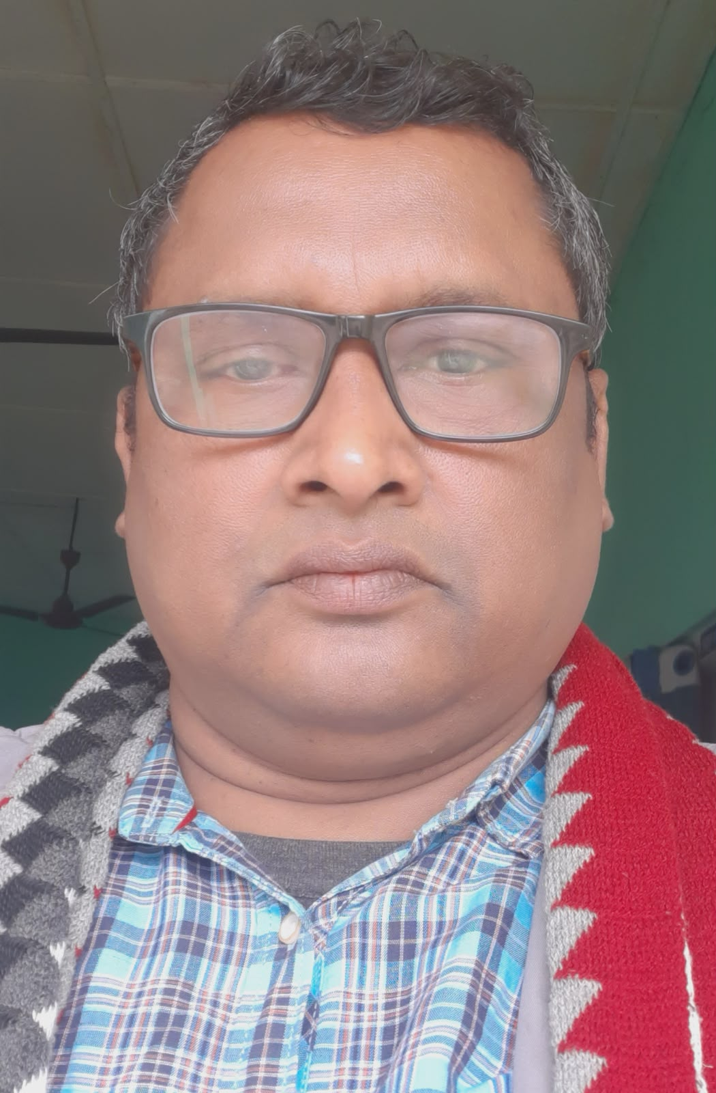
- Personal Information:
- Name : UTPAL BORAH
- Designation : Assistant Professor
- Department : Economics
- Date of Birth : 1st March , 1976
- Date of joining : 14th,August , 2004
- Nationality : Indian
- Contact Details:
- E-mail Id : uborah91@.gmail.com
- Phone number : 8638209440
- Address : Hatigarh Nawsolia Gaon

- Areas of specialization/ interest: Demography
- Educational qualifications
- Education:
Exam. | Subject | Board/University | Year of Passing
M. Phil, | Economics | VMU | 2010
Post-Graduation | Economics | Dibrugarh University | 1999
Graduation | Economics | Dibrugarh University | 1996
H. S. | Assamese, English, Economics, Political Science, History, Education | AHSEC | 1993
H. S. L. C. | Assamese, English, Science, Mathematics, Social study, History | SEBA | 1991

- Teaching Experience:
- Teaching Experience (within organization)
Name of the Institution | Designation | Organization Unit | Duration | Status
Dr. Nobin Bordoloi College | Assistant Professor | Affiliated University  (Higher Education) | From 14-08-2024 to till date. | Presently Working

- Administrative Experience:
- Administrative Experience within organization:
Institution | Designation | Assignment | Duration | Remarks | Status
Dr. Nobin Bordoloi College | Member | Campus Maintenance Cell | 2017-2022 | Successfully completed
Dr. Nobin Bordoloi College | Coordinator | Campus Maintenance Cell | 2024 | Successfully completed
Dr. Nobin Bordoloi College | Member | Students’ Intellectual Development Cell | 2018-2019 | Successfully completed
Dr. Nobin Bordoloi College | Member | Planning Committee, Coordinator of Internal Audit Committee | 2018-2019 | Successfully completed
Dr. Nobin Bordoloi College | Member | Media and Personal Relation Committee | 2018-2019 | Successfully completed
Dr. Nobin Bordoloi College | Member | Media and Personal Relation Committee | 2018-2019 | Successfully completed
Dr. Nobin Bordoloi College | Coordinator | Internal Examination Committee | 2019-2021 | Successfully completed
Dr. Nobin Bordoloi College | Member | Academic & Admission Committee & Disciplinary Committee | 2019-2021 | Successfully completed
Dr. Nobin Bordoloi College | Joint Coordinator | Campus Maintenance Cell | 2025 onward | Presently Working
Dr. Nobin Bordoloi College | Adviser | Multipurpose Cooperative Society Ltd | 2023-2025 | Successfully completed
Dr. Nobin Bordoloi College | President | Multipurpose Cooperative Society Ltd. | 2025 onward | Presently Working
Dr. Nobin Bordoloi College | Coordinator | SFC, Plantation & Vermiompost | 2025-2026 | Successfully completed
Dr. Nobin Bordoloi College | Member | Anti-raging Committee | 2025 onward | Presently Working
Dr. Nobin Bordoloi College | Member | Construction & Purchase Committee | 2025 onward | Presently Working
Dr. Nobin Bordoloi College | Member | Literary Club | 2025 onward | Presently Working

- Administrative Experience outside the parent institution:
Institution | Designation | Types | Assignment | Duration | Status
Election Commission of India. | Presiding Officer, Counter in-charge, Counting Supervisor | Election Duty | Presiding Officer, Counter in-charge, Counting Supervisor | From 2012

- Teaching Activities:
- Involvement in the University Activities:
Nature of Activity | Description | Duration | Status
Evaluation | Odd-Even Semester Answer scripts evaluation | 2012-till date | Active
Question Paper Setting | Question Paper Setting | 2024-till date | Active
Counselor(KKHSOU) | Counselor in Economics( KKHSOU) | Since 2012 | Active
Counsellor of Under Graduate and Post Graduate Subject (KKHSOU) | Counsellor | Since 2016 | Active

- Participation in Extension Activities (other Research Activities):

Name of Activity | Organizing Body | Collaborating Body | Date of Activity
Green Earth Plantation Drive | Dept. of Economics | IQAC | 07-11-2020,  02-08-2022,  02-05-2023,
Field Study | Dept. of Economics | Dept. of Economics, Assamese, Education | Yearly

- Publications other than Articles:

Types of Publications | Title of Publications | Book Name | ISBN/  e-ISBN | Publisher | Level | Editor | Digital Object Identifier (DOI)
Book | Unika Publication | Microfinance and Self Help Group Management | ISBN:978-93-91883-77-5 | Unika Publication | Local | Dr.Rofique Ahmed

- Seminar/Conference Details/Workshops/Webinar: FDP, workshops, Symposiums, educational conclaves organized by National & International institutions.
- Participated more than 7 national seminar and webinar through offline and online
- Self-declaration:
I hereby declare that the information provided above is true to the best of my knowledge.

Signature: Utpal Borah
Date: 02/05/2026

