Faculty’s Profile – Sanjib Rajkhowa
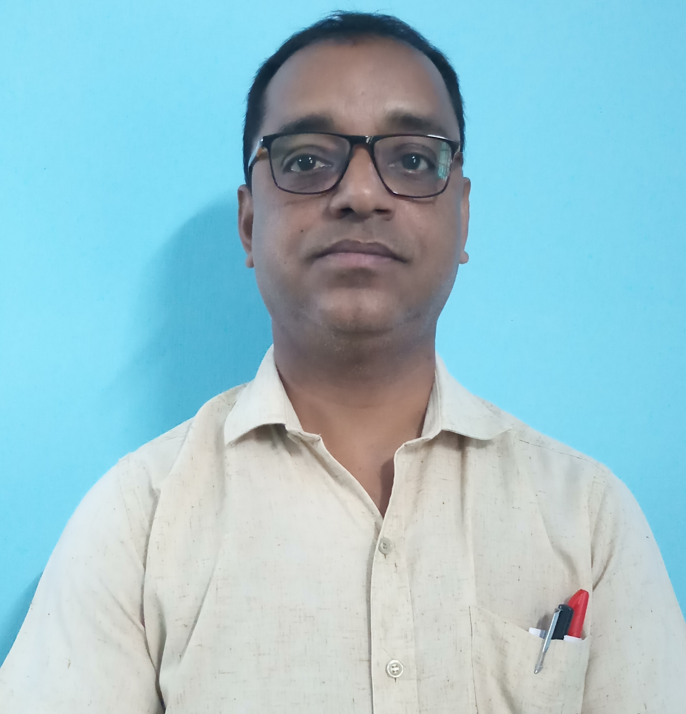
- Personal Information:
- Name : SANJIB RAJKHOWA
- Designation : Assistant Professor
- Department : English
- Date of Birth : 05-02-1980
- Date of joining : 15-09-2010
- Nationality : Indian
- Marital Status : Married
- Sex : Male
- Category : General
- Religion : Hinduism
- Language Known : Assamese, English, Hindi, Marathi
- Contact Details:
- E-mail Id : sanjibrajkhowa777@gmail.com
- Phone number : 91019 67664
- Address : Titabor Tiniali, Jorhat, Assam, Pin Code-785630
- About Me (Biography) :
Parents:
- Fathers’ Name : Anil Rajkhowa
- Mothers’ Name : Putu Devi
- Spouse’s Name : Bondona Mahanta
Permanent Address : Titabar Tini Ali
P.O.: Titabar P.S.: Titabar
Dist: Jorhat State: Assam
Pin: 785630
Address for Correspondence : -DO-

- Areas of specialization/ interest:
- Cricket
- Music
- Listening Music

- Educational qualifications
- Education:
Exam. | Subject | Board/University | Year of Passing
Ph. D. |  | Assam down town University, Guwahati-9
Post-Graduation | English | Pune University | 2005
Graduation | English | Dibrugarah University | 2003
H. S. | English, Ass, Pol.Science, Economics, Education | AHSEC | 1997
H. S. L. C. | English, Ass, Soc. Science, Mathematics, Hindi | SEBA | 1995

- Teaching Experience:
- Teaching Experience (within organization)
Name of the Institution | Designation | Organization Unit | Duration | Status
Dr. N.B. College | Asst. Professor | Provincialized | 15-09-2010 to till date | Asst. Professor
Dr. N.B. College | Asst. Professor | Provincialized | 16-09-2022 to 15-09-2025 | Head of the Department

- Teaching Experience outside the parent organization
Institution | Designation | Department | Duration | Status
Titabor College Junior | Lecture | English | 5 Years | Venture
Gyanjyoti Commerce College, Titabor | Lecture | English | 3 Years | Guest Lecture

- Research Publication:

Publication Type | Publisher | Article Name | Journal Name | ISSN/  e-ISSN | Impact Factor | Published Date
Research Article | Jamshedpu, India, | Published an article entitled Sociocultural reflection of Assam in the poems of Mahim Bora: An analysis; | The Challenge" an International Journal of Arts, Culture, Language and Literature | ISSN 22789499. |  | January-June, 2015,
Research Article | Research Review Journal | Nature and Symbob-Two Aspects in the poems of Robert Frost, A Study | Research View International Journal of Multidisciplinary | eISSN  2455-3085 | 6.93 | Sept. 2025
Seminar Article | IQAC, MANDIA College, Borpeta.  PBULISHED BY Western PublicationValley | Personal Symbolism in the poems of Robert Frost and Mohim Bora:A Comparative Study of a Few Select Poems. | Education and Modernism: Shaping the Mind of Modern Society in India | ISBN  978-81-981853-1-0 |  | January,2026

- Professional Development Programmes:

Type | Attending/Organizing | Title of Programme | Sponsoring Institution | Organizing Institution | Duration
RC | Attending | Human Rights and Social Inclusion | UGC | MMTTC Jamia Miliya Islamiya University,New Delhi, 2024 | 15 Days
FDP | Attending | AI | ITC, Guwahati | Jorhat College, JORHAT | 7 Days
WORKSHOP | Attending |  |  | N.N. SAIKIA COLLEGE, TITABOR | 7 Days

- Self-declaration:
I hereby declare that the information provided above is true to the best of my knowledge.

Signature: Sanjib Rajkhowa
Date: 30/04/2026

