Faculty’s Profile – Mouchumi Borgohain
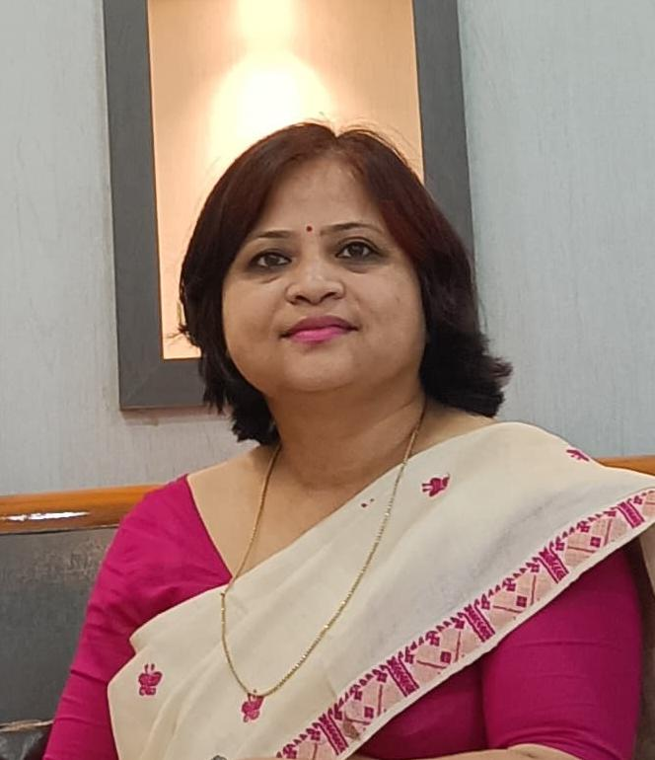
- Personal Information:
- Name : MOUCHUMI BORGOHAIN
- Designation : Assistant Professor
- Department : English
- Date of Birth : 03-09-1980
- Date of joining : 11-01-2010
- Nationality : Indian
- Contact Details:
- E-mail Id : mouchumi07@gmail.com
- Phone number : 8638956077
- Address : Garamur Na-Pam Gaon. P.O: J.E.C
- Areas of specialization/ interest:
i) Indian Writing In English
- Educational qualifications
- Education:
Exam. | Subject | Board/University | Year of Passing
Ph. D.
M. Phil, | English | Madurai Kamraj University | 2008
Post-Graduation | English | Pune University | 2004
Graduation | English | Dibrugarh University | 2001
H. S. | ENGLISH, ASSAMESE, POLITICAL SCIENCE, SOCIOLOGY, GEOGRAPHY, ECONOMICS | AHSEC | 1998
H. S. L. C. | ENGLISH, ASSAMESE, MATHS, GENERAL SCIENCE, SOCIAL STUDIES, HINDI | SEBA | 1996

- Teaching Experience:
- Teaching Experience (within organization)
Name of the Institution | Designation | Organization Unit | Duration
Dr Nobin Bordoloi College | Assistant Professor | English Department | 11-01-2010 To Presently Working
- Teaching Experience outside the parent organization
Institution | Designation | Department | Duration
Titaram Bordoloi High School | GUEST FACULTY | ENGLISH | 07-07-2023 To 10-07-2023
Charigaon Girls' High School | resource person | ENGLISH | 08-07-2019 To 09-07-2019
Sabaibandha High School | Attended as a Resource Person in the workshop for the students of class x organised by North Jorhat Senior Citizen Association | ENGLISH | 16-03-2018 To 17-03-2018
SUBARNA PROVA BORDOLOI GIRLS H.S SCHOOL | Guest faculty | ENGLISH | 08-08-2017 To 30-01-2018

- Administrative Experience:
- Administrative Experience within organization:
Institution | Designation | Assignment | Duration
Dr. Nobin Bordoloi College | H.O.D | Charge of Headship of the Department of English | 01-07-2019 To 13-09-2022
Dr. Nobin Bordoloi College | joint Co-ordinator of Extension Service Committee | joint Co-ordinator of Extension Service Committee | 01-07-2019 To 30-06-2020
Dr. Nobin Bordoloi College | Co-ordinator of Extension Service Committee | Co-ordinator Extension Service Committee | 01-07-2017 To 30-06-2018

- Administrative Experience outside the parent institution:
Institution | Designation | Types | Assignment | Duration
Gomati Devi Girls' H. S School | External Evaluator | Academic | Engagement as External Evaluator for Gunotsav-8 | 09-09-2018 To 11-09-2018
Mihiram Saikia H.S School | External Evaluator | Academic | Engagement as External Evaluator for Gunotsav-8 | 09-09-2018 To 11-09-2018
Krishna Kanta Handique State Open University | Member of Exam Management Committee | Academic | Serving as member of Exam Management Committee of the college Study Centre under KKHSOU | 01-06-2014 To 30-06-2025
Krishna Kanta Handique State Open University | Counsellor in English | Academic | Serving as Counsellor in English

- Involvement in the University Activities:
Nature of Activity | Description | Duration
Administrative responsibilities | Participated in the Women's Cell Coordinator's Meet organized by the UGC Centre for Women's Studies, Dibrugarh University, Dibrugarh | 31-08-2023 to 31-09-2023
Administrative responsibilities | Member of Internal Quality Assurance Cell | 09-10-2019 to30-11-2023
Administrative responsibilities | Member of Publication Committee | 01-07-2019 to 30-06-2020

- Association with Professional Bodies:

Name of Activity | Type | Name of Professional Agency | Year of Association | Duration
Assam Sahitya Sabha mainly focused on the all-round development of the Assamese language, literature and culture. | Art & literature | Assam Sahitya Sabha | 2018 | 720
Research Related Work | Mohan Chandra Mahanta Adhy, Ayayan Gobesona Kendra, a social science Research centre in collaboration with Cinnamara College | Mohan Chandra Mahanta Adhyayan Gobesona Kendra | 2013 | 1440

- Research Publication:
Publication Type | Publisher | Article Name | Journal Name | ISSN/  e-ISSN | Published Date
Research Papers in Peer Reviewed Journals | Dr Mujibul Hasan Siddiqui | The Impact of Social Environment in Mulk Raj Anand's Selected Novels: A Study | Excellence International Journal of Education and Research(EIJER) | 2349-8838 | 30-12-2018
Research Papers in Peer Reviewed Journals | Dimorian | Depiction of Dalit through the Character of Bakha in Mulk Raj Anand's Untouchable | Dimorian Review | eISSN: 2394-9163 | 01-06-2018

- Publications other than Articles:

Types of Publications | Title of Publications | Book Name | ISBN/  e-ISBN | Publisher | Editor
Edited/  Translated | A Perspective On Integration : Culture Of North-East And South-East Asia | Myriad of Expression | 978-93-85439-45-2 | Published By Iqac Dr. Nobin Bordoloi College In Association With Bidya Bhawan, Jorhat | Jointly Edited By Minakshi Nath And Mouchumi Borgohain
Edited/Translated Books | Participation of Women In Decision Making in Raja Rao,s | Itihas ,  Vol.-ii | 978-93-84191-48-1 | Cinamara College Sakha Sahitya Sabha & Prakashan | Bhrigumoni Nath
Edited/Translated Books | A Perspective on the Folk-dances of Arunachal Pradesh | The Challange,, An international Journal of Art, Culture, Language and Literature | ISSN;2278-9499 | Prabha Publicatiopn,Jamshedpur | Manoj Kumar Pathak
Edited/Translated Books | Swami Vivekananda and his views on Women Empowerment | Sikshajyoti | ISSN; 2348-9588 | Cinnamara College Publication | jointly Edited by Ranu Borah Saikia and Tarun Saikia
Edited/Translated Books | Swami Vivekananda and his views on Women Empowerment | MEZANGKARI | ISSN-2278-604X | ADKW PUBLISHER | Dipankar Saikia

- Professional Development Programmes:
Type | Attending/  Organizing | Title of Programme | Sponsoring Institution | Organizing Institution | Duration
Faculty Development Programmes | Attendee | Use of ICT Tools For Classroom Teaching | Ministry of Electronics and Information Technology | E&ICT Academy IIT Guwahati in association with Jorhat Kendriya Mahavidyalaya | 0106-07-2019  -07-2019
Refresher Program | Attendee | Refresher Course in English "Reading Literature" | UGC | North Bengal University | 029-01-20189-01-2018
Faculty Development Programmes | Attendee | Entrepreneurship Development Institute Of India ,Ahmedabad | National Science & Technology Entrepreneurship Devolepment Board ,Department Of Science & Technology,Govt.Of India | KAZIRANGA UNIVERSITY | 15-12-2006-01-201817
Orientation Programme | Attendee | 107th Orientation Programme UGC sponsored | National Science & Technology Entrepreneurship Devolepment Board ,Department Of Science & Technology,Govt.Of India | Human Resource Development Centre Gauhati University, Guwahati | 23-11-20-12-20152015

- Seminar/Conference Details/Workshops/Webinar:

Activity | Type | Attending/Organizing | Level | Name of Workshops/Seminars | Duration
Workshops | TEACHING -LEARNING AND EVALUATION IN CHOICE BASED CREDIT SYSTEM

- Self-declaration:
I hereby declare that the information provided above is true to the best of my knowledge.

Signature: 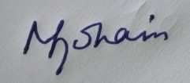
Date: 1-05-2026

