Faculty’s Profile – Muktarul Hoque
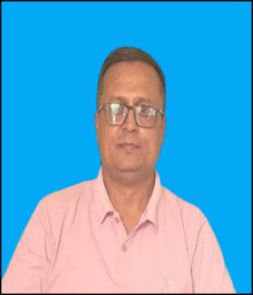
- Personal Information:
- Name : Md Muktarual Hoque
- Designation : Assistant Professor
- Department : Political Science
- Date of Birth : 03/06/1976
- Date of joining : 20/08/2001
- Nationality : Indian
- Contact Details:
- E-mail Id : muktarulhaque970@gmail.com
- Phone number : 9435630882
- Address :Titabar Tini Ali; Po: Titabar; Dist Jorhat; Pin: 785630
(Assam)
- Areas of specialization/ interest:
- International Politics
- Local self-Government
- Indian Administration
- Educational qualifications
- Education:
Exam. | Subject | Board/University | Year of Passing
Ph. D. | Political Science | Assam Down Town University | Work in Progress
M. Phil | Political Science | Vinayak Mission University | 2009
Post-Graduation | Political Science | Pune University | 2001
Graduation | Political Science (Major) | Dibrugarh University | 1997
H. S. | English, Assamese, Political Science, Economics, Education, Arabic | Assam Higher Secondary Education Council | 1994
H. S. L. C. | English, Assamese, Mathematics, Science, Social Science, Arabic | SEBA | 1992

- Teaching Experience:
- Teaching Experience (within organization)
Name of the Institution | Designation | Organization Unit | Duration | Status
Dr. Nobin Bordoloi College | Assistant Professor | College | From 2001 | In Service
- Talks/Poster Presented in the Conferences/Workshops:
Attending/Organizing | Level | Name of Activity | Date
IQAC Dr. Nobin Bordoloi College | State Level | Strategies For Quality Assurance of HEIs | 05/11/2022
N. N Saikia College | National Level (UGC Sponsored) | Human Rights Education | 22/10/2011
N. N Saikia College | International | Academic Research Writing, Copyright & Plagiarism | 14th to 19th November, 2021
IQAC, Batadraba SSS College | State Level | Research Methodology and Data Analysis | 18/02/2022
ACTA, Jorhat Zone | State Level | Revised Accreditation Framework, NAAC | 09/02/2022
Dr. Nobin Bordoloi College | National | Recent Trends in Social Science | 5th,6th , 7th march 2026
Dr. Nobin Bordoloi College | National | Intellectual Property Rights | 26th , 27th April 2026

- Seminar/Conference Details/Workshops/Webinar:
Activity | Attending/  Organizing | Level | Name of Workshops/Seminars | Duration
UGC Sponsored | N. N Saikia College | International | Environmental Issues and Sustainable Development: The Global and Indian Perspective | 2 days 3^{rd,} 4th may 2024
UGC Sponsored | Aligarh Muslim University | National | Muslim Education and Employment in the post-Scenario: Initiatives and Achievement | 1-2 Aug 2015
UGC Sponsored | Nakachari College | National | Ethnicity and Identity Crisis In North-East India | 5-6 May 2015
UGC Sponsored | Jhanji HNS College | International | Socio-cultural Assimilation in Northeast India and Southeast Asia | 30th April and 1st May 2018
UGC Sponsored | Furkating College | National | Governance, Civil Society & North-Eastern Region | 24th -25th June 2016

- Self-declaration:

I hereby declare that the information provided above is true to the best of my knowledge.

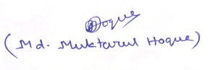
Signature:
Date: 08/05/2026

