Faculty’s Profile – Jonali Dutta Bhuyan
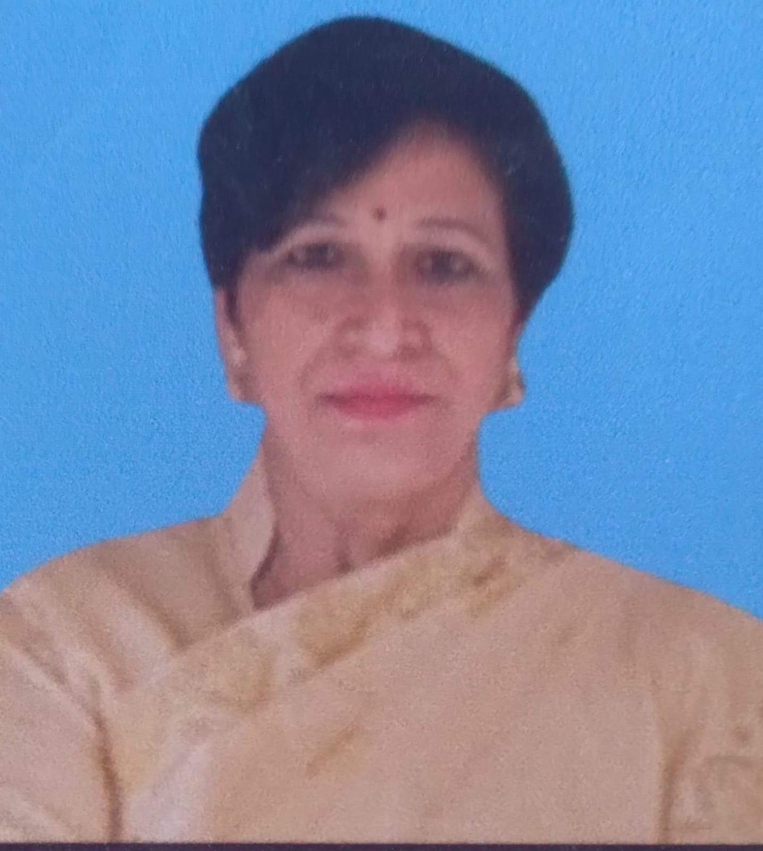

- Personal Information:
- Name : Jonali Dutta Bhuyan.
- Designation : Assistant Professor.
- Department : Assamese
- Date of Birth : 12/02/1972
- Date of joining : 18/03/1998
- Nationality : Indian
- Contact Details:
- E-mail Id : jonalijorhat2016@gmail.com
- Phone number : 7896533501
- Address : Rajamaidam Gajpuria Road, Jorhat-01
- About Me (Biography) : I am a woman in literary taste, but I am always interested in human language, language types and language related topics. I like to study about nature and green world.
- Areas of specialization/ interest:
- Language
- Folk music
- Folk lore
- Educational qualifications
- Education:
Exam. | Subject | Board/University | Year of Passing
Post-Graduation | Assamese (Linguistics) | Dibrugarh University | 1998
Graduation | Assamese (Honors) | Dibrugarh University | 1994
H. S. | Assamese, English, Economics, Pol. Science, Education and Adv. Assamese | AHSEC | 1992
H. S. L. C. | Assamese, English, Maths, Geography, History and General Science | SEBA | 1989

- Teaching Experience:
- Teaching Experience (within organization)
Name of the Institution | Designation | Organization Unit | Duration | Status
Dr. Nobin Bordoloi College | Assistant Professor |  | 1998-Present | Active

- Teaching Experience outside the parent organization
Institution | Designation | Department | Duration | Status
Borhola College | Guest Faculty | Assamese | - | N/A
SPB Girls High School | Guest Faculty | Assamese | - | N/A

- Administrative Experience:
- Administrative Experience within organization:
Institution | Designation | Assignment | Duration | Remarks | Status
Dr. Nobin Bordoloi College | Vice Principal | 07/04/2018 | 7 years | N/A | N/A

- Teaching Activities:
- Teaching:
Semester | Course Title | Activity Type | Credit
B.A 1st,2nd,3rd,4th,5th and 6th | Language and Literature | Teaching, Examiner, Question paper setter and all teaching related activities. | N/A

- Involvement in the University Activities:
Nature of Activity | Description | Duration | Status
Examiner | Examiner in B.A 1st to 6th semester | 1998-Present | Active

- Association with Professional Bodies:

Name of Activity | Type | Name of Professional Agency | Year of Association | Duration | Status
Assam Sahitya Sabha | Lifetime member | Assam Sahitya Sabha | 2017 | Lifetime | Active
Assam College Teachers Association | Member | ACTA | 2020 | 2020-Present | Active

- Participation in Extension Activities (other Research Activities):

Name of Activity | Organizing Body | Collaborating Body | Date of Activity
Gunotsav | Samagra Siksha Assam | Different schools | 2017, 2018, 2022, 2023

- Research Publication:

Publication Type | Publisher | Article Name | Journal Name | ISSN/e-ISSN | Whether UGC CARE listed? | Whether Peer reviewed or referred? | Published Date
Journal | Jhanji Hemnath Sarma College, Sivasagar, Assam | Bhasa Tattik Samparka: Asomiya Bhasa aru Dokhin pub Asia(Bodo aru Ahom bhasar ullekhonere) | Academia | 2349-3445 | No | Yes | July, 2022
Journal | Dr. Nobin Bordoloi College | Rongmilir hanhi uponyasot protifolito bhu-prokriti: ek somu bisleson | A Tapestry of Research: Weaving Together Multiple Perspectives | 978-93-92529-82-5 | No | No | December, 2025

- Publications other than Articles:

Types of Publications | Title of Publications | Book Name | ISBN/  e-ISBN | Publisher | Level | Editor | Digital Object Identifier (DOI)
Book | Modhyo jugor axomiya godyor sombhranto nidorshon: “Guru sorit kotha” kothaxoili | Myriad Of Expression | 978-93-85439-45-2 | Dr. Nobin Bordoloi College | National | Minakshi Nath,  Mouchumi Borgohain | N/A
Book | Women in literature in northeast India: Specially in Assam | Women in North-East India | 978-93-95103-52-7 | Sapekhati College | National | Tulumoni Chetia,  Dr. Bijumoni Dutta | N/A

- Professional Development Programmes:
Type | Attending/Organizing | Title of Programme | Sponsoring Institution | Organizing Institution | Duration
Orientation | Attending | Orientation Programme | HRDA UGC | Mizoram University | 1 month
Refresher | Attending | Refresher Course | HRDA UGC | Guwahati University | 1 month

- Seminar/Conference Details/Workshops/Webinar:

Activity | Type | Attending/Organizing | Level | Name of Workshops/Seminars | Duration  (Dates)
Paper Presented | Seminar | Attending | International | Socio-cultural Assimilation in Northeast India and Southeast Asia | 30th April to 01st May, 2018
Participation | Workshop | Attending | National | National Education Policy 2020 and Gandhian Educational Philosophy | 25th February to 03rd  March, 2021
Participation | Workshop | Attending | District | The concept of continuous evaluation and its implementation in semester system | 13th August, 2011
Paper Presented | Seminar | Attending | National | Reflection of freedom movement in Assamese literature | 22nd and 23rd September, 2023
Participation | Workshop | Attending | State | Revised Accreditation Framework, NAAC | 9th February, 2022
Paper Presented | Seminar | Attending | National | “Unexplored history of Indian Freedom Movement with special Reference to undivided Sivasagar District of Assam” | 24th December, 2021

- Self-declaration:
I hereby declare that the information provided above is true to the best of my knowledge.

Signature:
Jonali Dutta Bhuyan
Date: 30/04/2026

