Faculty’s Profile – Dr. Sajib Saikia
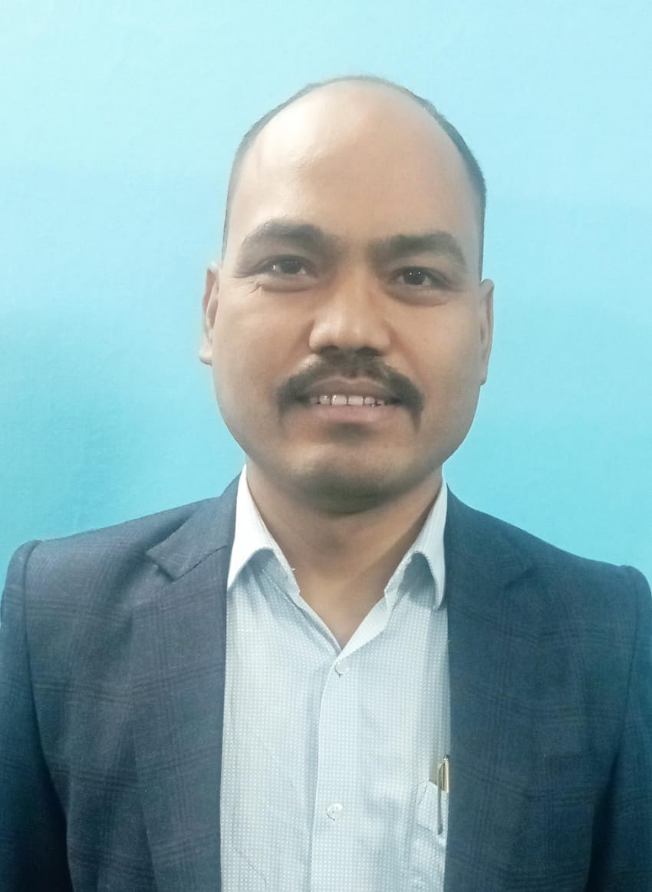
- Personal Information:
- Name : Dr.Sanjib Saikia
- Designation : Assistant Professor
- Department : Political Science
- Date of Birth : 31-12-1984
- Date of joining : 17-09-2010
- Nationality : Indian
- Contact Details:
- E-mail Id : ssaikia205@gmail.com
- Phone number : 8473880050
- Address : VILL- BHAGYALAKHI, P.O PHULBARI, JORHAT,
Assam, 785630
- Educational qualifications
- Education:
Exam. | Subject | Board/University | Year of Passing
Ph. D. | Political Science | Dibrugarh University | 2018
Post-Graduation | Political Science | Guwahati University | 2007
Graduation | Political Science(M) | Dibrugarh University | 2005
H. S. | Assamese, English, Political Science, Education, History | AHSEC | 2002
H. S. L. C. | Assamese, English, G. Mathematics, G. Science, Hindi, Social Studies | SEBA | 2000

- Qualification:
Exam. | Date of Passing | Conducted by | Certificate No.
NET | 28-12-2008 | UGC | 080648

- Teaching Experience:
- Teaching Experience (within organization)
Name of the Institution | Designation | Organization Unit | Duration | Status
Dr. Nobin Bordoloi College | Assistant Professor | Political Science | 17-09-2010 till the date
- Teaching Experience outside the parent organization
Institution | Designation | Department | Duration | Status
Office of the THENGAL KACHARI Autonomous Council | Nominated Member of the walk-in- interview | GOVT. OF ASSAM Office of the THENGAL KACHARI Autonomous Council | 05-01-2024 To 08-01-2024
Borholla College | Assistant Professor | Department of Political Science Borholla College | 23-06-2022 To 24-06-2022
Dr. Nobin Bordoloi College Study Centre | GUEST FACULTY | Krisna Kanta Handique State Open University Study Centre: Dr. Nobin Bordoloi College | 12-11-2014 To 22-02-2025

- Administrative Experience:
- Administrative Experience within organization:
Institution | Designation | Assignment | Duration | Remarks | Status
Dr. Nobin Bordoloi College | Nodal Teacher of electoral Literacy Club | Nodal Teacher of electoral Literacy Club | 22-12-2023 To 19-04-2024 | Approved
Dr. Nobin Bordoloi College | Head of the Department of Political Science | Department related all Work | 22-09-2022 To 20-08-2024 | Approved
Dr. Nobin Bordoloi College | Coordinator | Worked as Coordinator, Campus Maintenance Cell | 01-07-2018 To 30-06-2019 | Approved
Dr. Nobin Bordoloi College | Coordinator | Worked as Coordinator, Purchase Committee | 01-07-2015 To 30-06-2016 | Approved
Dr. Nobin Bordoloi College | Joint coordinator | Worked as Joint Coordinator, Publication Committee | 01-07-2014 To 30-06-2015 | Approved
Dr. Nobin Bordoloi College | Joint coordinator | Worked as Joint Coordinator, Publication Committee | 01-07-2013 To 30-06-2014
Dr. Nobin Bordoloi College | Student related co-curricular, extension and field based activities | Worked as Chief Advisor of the student union | 24-09-2024
Dr. Nobin Bordoloi College | Administrative responsibilities | Worked as Member Governance, Leadership and management-VI | 15-12-2023 to 30-06-2024
Dr. Nobin Bordoloi College | Administrative responsibilities | Worked as Member, Extension Service Committee | 01-07-2018 to 30-06-2019
Dr. Nobin Bordoloi College | Administrative responsibilities | Worked as Member Internal Examination Monitoring Committee | 01-07-2018 to 30-06-2019
Dr. Nobin Bordoloi College | Administrative responsibilities | worked as Member Anti Ragging Squad | 01-07-2018 to 30-06-2019
Dr. Nobin Bordoloi College | Administrative responsibilities | worked as Member Anti Ragging Squad | 01-07-2018 to 30-06-2019
Dr. Nobin Bordoloi College | Administrative responsibilities | Worked as Member, Health Care Committee | 01-07-2018 to 30-06-2019
Dr. Nobin Bordoloi College | Student related co-curricular, extension and field based activities | Worked as Care Taker Officer NCC | 01-07-2017 to 30-06-2018
Dr. Nobin Bordoloi College | Student related co-curricular, extension and field based activities | Worked as Care Taker Officer NCC | 01-07-2016 to 30-06-2017
Dr. Nobin Bordoloi College | Administrative responsibilities | Worked as Member Library Committee | 01-07-2015 to 30-06-2016
Dr. Nobin Bordoloi College | Administrative responsibilities | Worked as Member Publication Committee | 01-07-2015 to 30-06-2016
Dr. Nobin Bordoloi College | Administrative responsibilities | Worked as Member Library Committee | 01-07-2014 to 30-06-2015
Dr. Nobin Bordoloi College | Administrative responsibilities | Worked as Member Anti- Ragging Committee | 01-07-2014 to 30-06-2015
Dr. Nobin Bordoloi College | Administrative responsibilities | Worked as Member, Campus Maintenance Cell | 01-07-2013 to 30-06-2014
Dr. Nobin Bordoloi College | Administrative responsibilities | Worked as Member Library Committee | 01-07-2013 to 30-06-2014

- Administrative Experience outside the parent institution:
Institution | Designation | Types | Assignment | Duration | Status
Krisna Kanta Handique State Open University Study Centre:Dr. Nobin Bordoloi College | Member Of Management Committee | Academic | Worked As An Active Member Of Management Committee Of The Study Centre Of Krishna Kanta Handique State Open University For All Undergraduate And Postgraduate Programme. | 15-10-2014 To 22-02-2025

14) Research Publication:
Publication Type | Publisher | Article Name | Journal Name | Digital Object Identifier (DOI) | ISSN/e-ISSN | Impact Factor | Published Date
Research Papers in Care Listed Journals | Tagore Gandhi Institute The Shakespeare Society Of Eastern India | Indias Diplomatic Approach Mediating The Isreal/ Gaza Conflict | International Journal Of Cutural Studies And Social Sciences |  | 2347-4777 |  | 05-01-2024
Research Papers in Peer Reviewed Journals | Journal of Intellectual(JOI) | The Influence of Ethnicity on Electoral Politics in Assam | Journal of Intellectual(JOI) |  | 2583-7427 |  | 25-12-2023
Research Papers in Scopus Listed Journals | Official Of International Association Of Food And Nutrition Sciences | Economic Implication Of Climate Change On Agricultural Crops | IJFANS |  | 2320-7876 | 7.832 | 01-12-2023
Research Papers in Care Listed Journals | Academy For Humanities And Social Science(AHSS) | Local Economic Devolpment Through Panchayati Raj.. And Analisis In Assam | Humanities And Social Science Studies |  |  |  | 01-07-2023
Research Papers in Peer Reviewed Journals | JETIR | Climate Change and Its Implications for Agricultural Livelihoods with Reference to Assam | Journal of Emerging Technologies and Innovative Research |  | 2349-5162 | 7.95 | 14-06-2017
Research Papers in Peer Reviewed Journals | IJCRT | Cultural Preservation Among Indigenous Ethnic Communities In Assam | International Journal of Creative Research Thoughts |  | 2320-2882 | 7.97 | 01-09-2018

15) Publications other than Articles:
Types of Publications | Title of Publications | Book Name | ISBN/e-ISBN | Publisher | Level | Editor
Chapters in Books | Third Sex and Human Rights: In Indian Context | Prospects of Political and Society | 81-924140-5-1 | SPS Education India Pvt. Ltd. | Local Publishers | Joy Prakash Oza
Edited/Translated Books | Public Policy In India |  | 978-93-93843-84-5 | Manab Publications | Local Publishers
Chapters in Books | Indian Government And Politics | INDIAN GOVERNMENT AND POLITICS | 978-93-91883-73-7 | Unika Prakashan | Local Publishers
Text/Reference/Subject Books/Other | ভাৰতবৰ্ষত ৰাজনৈতিক প্ৰক্ৰিয়া | ভাৰতবৰ্ষত ৰাজনৈতিক প্ৰক্ৰিয়া | 976-93-91883-58-4 | Unika Prakashan | Local Publishers
Chapters in Books | ৰাজনৈতিক তত্ত্বঃ ধাৰণা আৰু বিতৰ্ক | ৰাজনৈতিক তত্ত্বঃ ধাৰণা আৰু বিতৰ্ক | 978-93-91883-65-2 | Unika Prakashan | Local Publishers
Chapters in Books | Deepening Democracy In India By Building Gender Equality In Politics | The Indian Journal Of Political Science | 019-5510 | IJPS | Local Publishers
Chapters in Books | India's Diplomatic Approach in Mediating The Israel-Gaza Conflict | International journal of cultural studies and social sciences | 2347-4777 | Tagore Gandhi Institute | International
Chapters in Books | Local Economic Development Through Panchayati Raj : An Analysis In Assam | Humanities And Social Science Studies | 2319-829X | Unika Prakashan | Local Publishers
Chapters in Books | Classical Political Philosophy | Classical Political Philosophy | 978-93-91883-73-7 | Manab Publication | Local Publishers

19) Professional Development Programmes:
Type | Attending/  Organizing | Title of Programme | Sponsoring Institution | Organizing Institution | Duration
Refresher Program | Attendee | Human Rights And Social Inclusion (Interdisciplinary) | MMTTC | Jamia Millia Islamia New Delhi | 06-06-2024 to 21-06-2024
Refresher Program | Attendee | Refresher Course on Human Rights & Social Inclusion Interdisciplinary | MMTTC | Malaviya Mission Teacher Training Programme | 06-06-2024 to 21-06-2024
Orientation Programme | Attendee | NEP 2020 Orientation & Sensitization Programme | MMTTC | Malaviya Mission Teacher Training Center | 20-05-2024 to 29-05-2024
Faculty Development Programmes | Attendee | Faculty Induction Programme | UGC | UGC Human Resource Development Centre, Aligarh Muslim University | 08-02-2022 to 12-03-2022
Faculty Development Programmes | Attendee | Resilience, Resurgence & Revival Measures for Unorganized Sector: A Roadmap to Self-Reliant India |  | Department of Commerce, Rajiv Gandhi University(A Central University)Itanagar, Arunachal Pradesh, India | 24-08-2020 to 29-08-2020
Orientation Programme | Attendee | Orientation/Refresher Course of National Service Scheme(NSS) | Ministry of youth Affairs & Sports, Government of India | Indian Institute of Entrepreneurship | 02-02-2020 to 08-02-2020
Short Term Program | Attendee | Indian Institute Of Entrepreneurship | Ministry of Youth Affairs & Sports, Govt. Of India | National Service Scheme | 02-02-2020 to 08-02-2020
Orientation Programme | Attendee | Orientation Course for Programme Officers National Service Scheme |  | Ministry of skill Development & Entrepreneurship Govt. of India | 02-02-2020 to 08-02-2020

21) Seminar/Conference Details/Workshops/Webinar:
Activity | Type | Attending/  Organizing | Level | Name of Workshops/Seminars | Duration
Seminars | Industry-Academic Innovative Practices | Presented | International within country | Cultural Heritage Of India: Reflection On Society And Literature
Seminars | Industry-Academic Innovative Practices | Presented | International within country | Environmental Issues and sustainable Development: The Global and Indian perspectives
Workshops | Industry-Academic Innovative Practices | Presented | International within country | Academic Research Writing, Copyright & Plagiarism | 14-11-2022 to 19-11-2022
Seminars | Industry-Academic Innovative Practices | Presented | National | Exploring the Role of Subhas Chandra Bose in the Second World War and Freedom Movement of India With Special Reference To North East India | 29-03-2022 to 30-03-2022
Workshops | Industry-Academic Innovative Practices | Presented | International within country | State Level workshop on Revised Accreditation Framework NAAC | 09-02-2022
Workshops | Industry-Academic Innovative Practices | Presented | National | Trends In Teaching Learning, Institution Building And Innovations At Higher Educational Institution | 22-06-2021 to 27-06-2021
Workshops | Industry-Academic Innovative Practices | Presented | National | Research Methodology and Training Programme in Social Science Research
Seminars | Industry-Academic Innovative Practices | Presented | International_within_country | On Socio-Economic Development and Women Empowerment
Workshops | Industry-Academic Innovative Practices | Presented | International_within_countryc | Implementation of CBSC System In The Colleges Under Dibrugarh University | 04-11-2016
Workshops | Industry-Academic Innovative Practices | Presented | National | National Workshop on Human Rights: Issues, Prospects And Challenges | 26-08-2016 to 01-09-2016
Seminars | Industry-Academic Innovative Practices | Presented | National | National Seminar On Democratic Decentralisation And Rural Development In Northeast India

23) Self-declaration:
I hereby declare that the information provided above is true to the best of my knowledge.

Signature: 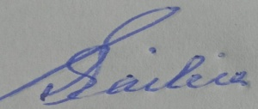
Date: 03/0502026

