Faculty’s Profile – Dr. Himanta Pratim Borgohain
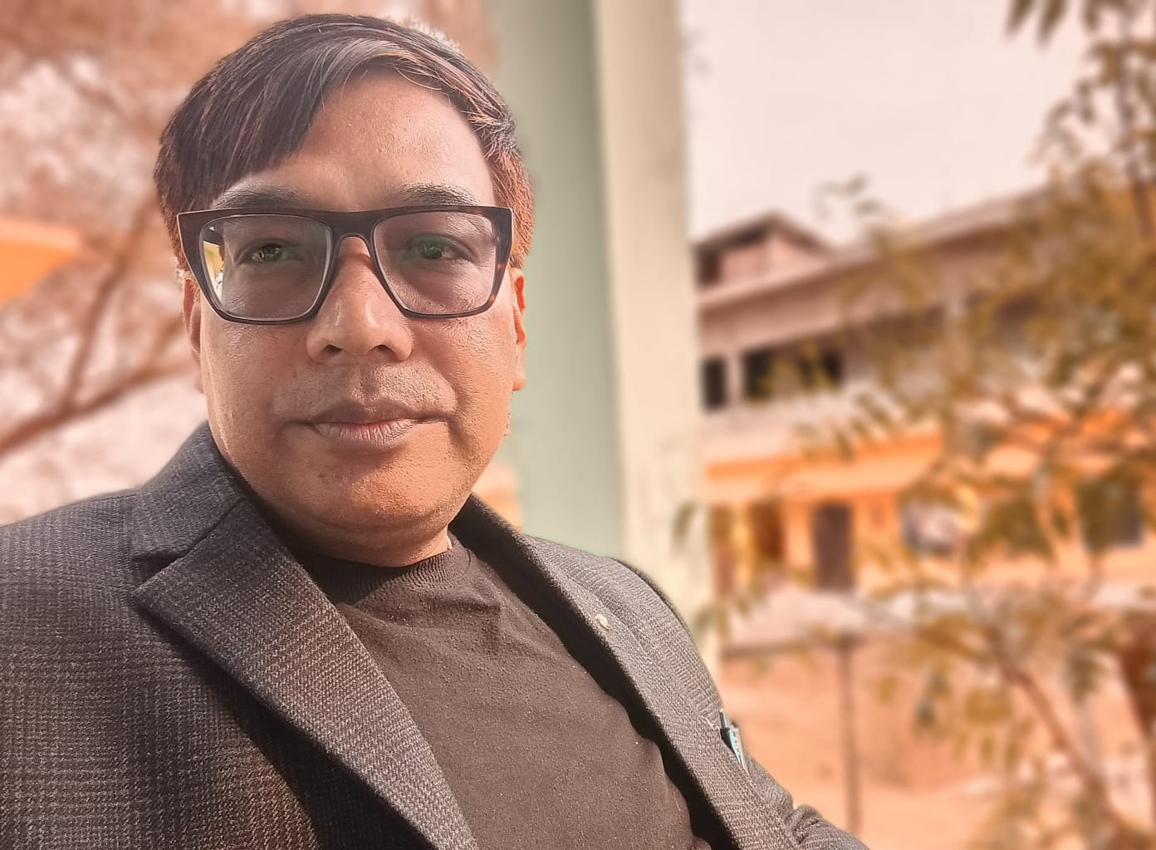

- Personal Information:
- Name : Dr. Himanta Pratim Borgohain
- Designation : Assistant Professor & HoD
- Department : Sociology
- Date of Birth : 01/12/1978 :
- Date of joining : 26/01/2010
- Nationality : Indian
- Contact Details:
- E-mail Id : borgohainhimanta38@gmail.com
- Phone number : 6900907667/8474887475
- Address : Lahdoigarh, Jorhat, Assam PIN:785700
- About Me (Biography) : Blood Group- B⁺, Height: 6 ft,
Identification Mark: A black mole over right chin,

- Areas of specialization/ interest:
i) Sociological Theories
ii) Sociological Research
iii) Social Psychology, Criminology and Victimology
- Educational qualifications
- Education:
Exam. | Subject | Board/University | Year of Passing
Ph. D. | Sociology | Dibrugarh University | 2015
M. Phil, | Sociology | Madurai Kamraj University | 2008
Post-Graduation | Sociology | Dibrugarh University | 2002
Graduation | Sociology | Dibrugarh University | 1999
H. S. | Eng, Ass, Soc,Edn, Eco. Psc, | AHSEC | 1996
H. S. L. C. | Eng. Ass. Math. GScn. Soc.Studies. Hindi | SEBA | 1994

- Other Qualification:
Exam. | Date of Passing | Conducted by | Certificate No.
SLET | 6th Feb. 2013 | SLET Commission | 605
- Teaching Experience:
- Teaching Experience (within organization)
Name of the Institution | Designation | Organization Unit | Duration | Status
Dr. Nobin Bordoloi College | Asstt. Professor | Govt. | 15 years | Continuing

- Administrative Experience:
- Administrative Experience within organization:
Institution | Designation | Assignment | Duration | Remarks | Status
Dr. Nobin Bordoloi College | IQAC Coordinator |  | 5 years | During the tenure facing 1st Cycle of Assessment & Accreditation of NAAC the HEI was Graded with B⁺ | Resigned
Dr. Nobin Bordoloi College | HoD of Sociology |  | 1 year |  | Continuing

- Teaching Activities:
- Teaching:
Semester | Course Title | Activity Type | Credit
BA 1st Major | Introduction to Sociology-I- | Lectures & Tutorials | 4
BA 1st Minor | Sociological Perspectives | Do | 4
BA 1st GEC | Introduction to Sociology | Do | 3
BA 2nd Major | Introduction to Sociology-II | Do | 4
BA 2nd Minor | Sociology of India | Do | 4
BA 2nd GEC | Indian Society: Reality and Images | Do | 3
BA 3rd Major | Sociology of India-II | Do- | -4
BA 3rd Minor | Methods of Sociological Enquiry | Do | 4
BA 3rd GEC | Marriage, Family and Kinship | Do | 3
BA 4th Major | Sociological Research Methods-I | Do | 4
BA 4th Minor | Economy and Society | Do | 4
BA 5th Major | Sociology of Kinship- | Do- | -4
BA 5th Major | Political Sociology | Do | 4
BA 5th Major | Sociological Research Methods-II | Do | 4
BA 5th Minor | Polity and Society in India | Do | 4
BA 6th Major | Urban Sociology | Do | 4
BA 6th Minor | Gender and Sexuality | Do | 4
- Involvement in the University Activities:
Nature of Activity | Description | Duration | Status
Question Paper Setter |  | 4 years
Observer of Inter-College Men Football Tournament 2025-26 | Observer | 15 Days

- Association with Professional Bodies:

Name of Activity | Type | Name of Professional Agency | Year of Association | Duration | Status
Life Member |  | UNESCO | 29/04/2024 | 2 YEARS | Contd.
Life Member |  | MCMAGK, Cinnamara College | 02/07/2025 | 1 YEAR | Contd.

- Research Publication:

Publication Type | Publisher | Article Name | Journal Name | ISSN/e-ISSN | Whether UGC CARE listed? | Whether Peer reviewed or referred? | Impact  Factor | Published Date
Journal | Asia pacific Association of Psychology | ‘Social Stratification and Inequality in Modern Societies- Assam Perspective’ | Indian journal of Psychology | ISSN-0091-5553 | YES | YES |  | 2025

- Publications other than Articles:

Types of Publications | Title of Publications | Book Name | ISBN/  e-ISBN | Publisher | Level | Editor
Book | ‘The Culture of the Ahoms: An Analytical Study’ | Unfolding Realities | 978-93-6095-934-0 | Authors Press, New Delhi | National | Dr. Dhurbajyoti Saikis  Dr. Lucky Chetia
Book |  | A Tapestry of Research | 978-93-92529-82-5 | Sabda Prakash, Jorhat | National | Dr. Himanta Pratim Borgohain

- Policy Documents:

Description | Level | Submitted to | Submission Date
FYUGP Syllabus Upgradation | State | HoD of Sociology, Dibrugarh University | 28th March, 2026

- Professional Development Programmes:
Type | Attending/  Organizing | Title of Programme | Sponsoring Institution | Organizing Institution | Duration
International | Attended | Current Issues & Perspectives of Environmental Remediation | UGC-MMTTC | DBT_IBT Hub, Nanda Nath saikia College | 7 Days

- Talks/Poster Presented in the Conferences/Workshops:
Attending/Organizing | Level | Name of Activity | Date
Organized | National | Convenor | 5th, 6th & 7th March, 2026
Attended | State | Resource Person | 31/10/2025

- Seminar/Conference Details/Workshops/Webinar:

Activity | Type | Attending/  Organizing | Level | Name of Workshops/Seminars | Duration  (Dates)
Participated | Workshop | Attended | National | IKS | 7 Days
Participated | Workshop | Attended | National | Research Projects, Fund Acquisition, Effective Strategies, Techniques and Smart Interactions | 7 Days
Presented Paper | Seminar | Attended | National | Tribal Communities of the North East India in the Perspective of Globalization | 2 Days
Presented Paper | Seminar | Attended | National | Relocating Unsung Heroes from North East India | 2 Days
Participated Paper | Symposium | Attended | International | Language and Ineqaualities inSouth Asia | 1 Day
Presented Paper | Seminar | Attended | International | Cultural Heritage of India | 1 Day
Presented Paper | Seminar | Attended | International | Exploring Indian Knowledge System | 1 Day
Presented Paper | Conference | Attended | International | Science, Society and Sustainibilty | 2 Days

- Additional Links:
• Google Scholar : Dr. Himanta Pratim Borgohain
• LinkedIn Profile : DR. Himanta P. Borgohain

- Self-declaration:
I hereby declare that the information provided above is true to the best of my knowledge.

Signature: Dr. Himanta Pratim Borgohain
Date: 01/05/2026

