Faculty’s Profile – Biswajit Neog

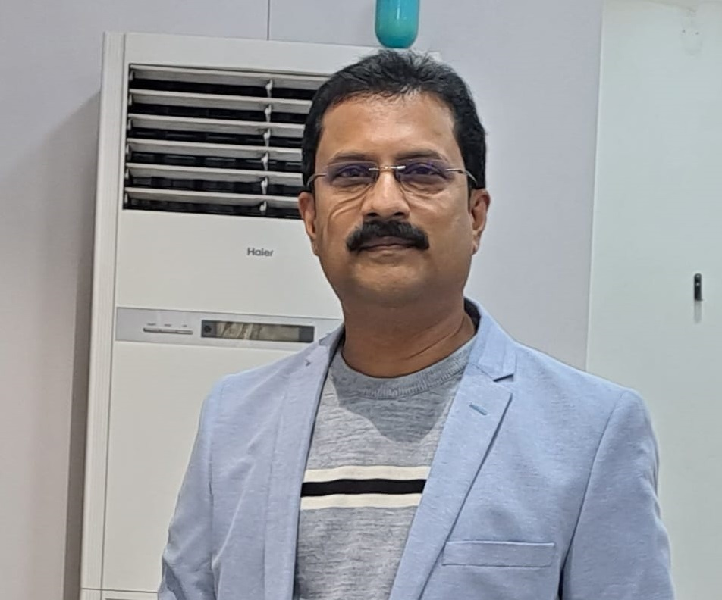
- Personal Information:
- Name : BISWAJIT NEOG
- Designation : Assistant Professor
- Department : English
- Date of Birth : 01-02-1977
- Date of joining : 25-08-2003
- Nationality : Indian
- Contact Details:
- E-mail Id : biswajitneog77@gmail.com
- Phone number : 8638540928
- Address : Charigaon kathaniarkuri, P.O Chengaligaon, Jorhat, Assam,
PIN: 785010
- Areas of specialization/ interest:
i) Indian writing in English.
ii) Indian Classical Literature.
iii) Sankardeva Studies.
- Educational qualifications
- Education:
Exam. | Subject | Board/University | Year of Passing
M. Phil, | English | VINAYAKA MISSIONS UNIVERSITY | 2008
Post-Graduation | English | Dibrugarh University | 2001
Post-Graduation | English | Vinayaka Missions University | 2011
Graduation | English | Dibrugarh University | 1997
H. S. | Mil(Assamese), English, Education, Economics, Political Science, | Assam Higher Secondary Education Council | 1994
H. S. L. C. | Mil(Assamese), English, General Science, General Mathematics, Social Studies, History | Board of Secondary Education | 1992

- Teaching Experience:
- Teaching Experience (within organization)
Name of the Institution | Designation | Organization Unit | Duration | Status
Dr. Nobin Bordoloi College | Assistant Professor | Dibrugarh University | 25-08-2003 To Presently Working | Active

- Teaching Experience outside the parent organization
Institution | Designation | Department | Duration
Charigaon Girls' High School | Resource Person | English | 08-07-2019 to 09-07-2019
Jorhat Balya Bhawan | Resource Person | English | 28-07-2018 to 29-07-2018
Sarbaibandha High School | Resource Person | English | 16-03-2018 to 17-03-2018
Subarnaprobha Girls' Higher Secondary School | Guest Faculty | English | 01-08-2017 to 25-08-2017
Charigaon Girls' High School | Resource Person | English | 09-07-2016 to 10-07-2016
Dr. Nobin Bordoloi College | Guest Faculty | English | 10-11-2012 to 22-02-2025

- Administrative Experience:
- Administrative Experience within organization:
Institution | Designation | Assignment | Duration | Remarks
Dr. Nobin Bordoloi College | Head of the Department of English | Served as the Head of the Department of English in Dr. Nobin  Bordoloi College | 25-08-2018 to 30-06-2019 | Approve
Dr. Nobin Bordoloi College | Coordinator, Planning Committee | Worked as Coordinator, Planning Committee of the college | 01-06-2018 to 31-05-2019 | Approve
Dr. Nobin Bordoloi College | Coordinator of Internal Quality Assurance Cell | Worked for overall development of the college | 02-05-2018 To 01-05-2019 | Approve
Dr. Nobin Bordoloi College | Head of the Department of English | Served as the Head of the Department of English in Dr. Nobin Bordoloi College | 25-08-2017 To 24-08-2018 | Approve
Dr. Nobin Bordoloi College | Co-ordinator, Construction Committee | Worked as Co-Ordinator, Construction Committee of the college | Dr. Nobin Bordoloi College | Approve
Dr. Nobin Bordoloi College | Coordinator, Planning Committee | Worked as Coordinator, Planning Committee of the college | 01-06-2017 To 31-05-2018 | Approve
Dr. Nobin Bordoloi College | Coordinator of Internal Quality Assurance Cell | Worked for overall development of the college | 02-05-2017 To 01-05-2018 | Approve
Dr. Nobin Bordoloi College | College Nodal Officer of AISHE | Submitted college data on AISHE portal | 01-01-2017 | Approve
Dr. Nobin Bordoloi College | Head of the Department of English | Served as the Head of the Department of English in Dr. Nobin Bordoloi College | 25-08-2016 To 24-08-2017 | Approve
Dr. Nobin Bordoloi College | Coordinator, Planning Committee | Worked as Coordinator, Planning Committee of the college | Dr. Nobin Bordoloi College | Approve
Dr. Nobin Bordoloi College | Coordinator, Construction Committee | Worked as Coordinator, Construction Committee of the college | 01-06-2016 To 31-05-2017 | Approve
Dr. Nobin Bordoloi College | Coordinator of Internal Quality Assurance Cell | Worked for overall development of the college | 02-05-2016 To 01-05-2017 | Approve
Dr. Nobin Bordoloi College | Head of the Department of English | Served as the Head of the Department of English in Dr. Nobin Bordoloi College | 25-08-2015 To 24-08-2016 | Approve
Dr. Nobin Bordoloi College | Joint coordinator, Media and Personal Relation Committee | Worked as Joint coordinator, Media and Personal Relation Committee of the college | 01-07-2015 To 30-06-2016 | Approve

- Administrative Experience outside the parent institution:

Institution | Designation | Types | Assignment | Duration
Krishi Mazdoor LPS, Hautley LPS, Sahmilon Adarsha LPS, Golaghat District | External Evaluator | Academic | Worked as external evaluator of Gunotsav programme in the three schools of Golaghat district | 04-01-2018 To 06-01-2018
Chungi Banua Lp, Chungi Chah Mazdoor Lp, Dhubuni Lps of Titabor Education Block of Jorhat | External Evaluator | Academic | Worked as external evaluation in three schools in Titabor block of Jorhat district | 11-10-2017 To 13-10-2017
Krisna Kanta Handique State Open University Study Centre:Dr. Nobin Bordoloi College | Member of Management Committee | Academic | Worked as an active member of management committee of the study centre of Krisna Kanta Handique State Open University for all undergraduate and postgraduate PROGAMMES | 01-01-2012 To 31-12-2023

- Teaching Activities:
- Involvement in the University Activities:
Nature of Activity | Description | Duration
Administrative responsibilities | Worked as member to Planning Committee of the college | 01-06-2019 to 31-05-2020
Administrative responsibilities | Worked as member to the Prospectus, Routine and Academic Calendar Committee of the college | 01-06-2019 to 31-05-2020
Administrative responsibilities | Worked as member to the Academic and Admission Committee of the college | 01-06-2019 to 31-05-2020

- Association with Professional Bodies:

Name of Activity | Type | Name of Professional Agency | Year of Association | Duration
Functioned as member to the Management Committee of Krishna Kanta Handique State Open University | Member, Management Committee | Krishna Kanta Handique State Open University | 2012 | 158

- Honour and Awards:

Award Name | Awarding Body | Award Category | Date | Level
Best Educationist Award For Talented Personalities | Economic Growth Foundation, New Delhi | Academic | 07-10-2017 | National

- Research Publication:
Publication Type | Publisher | Article Name | Journal Name | Digital Object Identifier (DOI) | ISSN/  e-ISSN | Published Date
Research Papers in Care Listed Journals | Granthaalayah Publications and Printers | Kazuo Ishiguro's Never Let Me Go: An Analysis through the Lens of Place | Shodh Kosh: Journal of Visual and Performing Arts | Prefix10.29121 | 2582-7472 | 01-05-2024
Research Papers in Peer Reviewed Journals | Dr. Mujibul Hasan Siddiqui | The Role Of Srimanta Sankardeva's Vaishnavite Religion And Culture To Foster Integration Among Various Ethnic Groups Of North East India: With Special Reference To Meghalaya | Excellence International Journal of Education And Research |  | 2349-8838 | 25-03-2018
Review Articles | Forum For English Studies | Making Of The Dramatist: Shakespeare's Indebtedness To His Predecessor | Excursus |  | 2319-1368 | 25-08-2016
Research Papers in UGC listed Journals | International Journals of Multidisciplinary Research Academy | Anita Desai's Fasting Feasting: An Analysis of Women's Subjugation in a Male Dominated Society | International Journal of Research in Social Sciences | www.ijmra.us | 2249-2496 | 01-04-2019
Review Articles | Dimorian Review Foundation, Sonapur,Dimoria, Kamrup(Metro), Assam-782402 | How Much Shakespeare Owed To His Predecessors: An Analysis | Dimorian Review |  | 2394-9163 | 01-03-2018

- Publications other than Articles:
Types of Publications | Title of Publications | Book Name | ISBN/  e-ISBN | Publisher | Level | Editor
Edited/  Translated Books | Sankardeva's Culture And Philosophy In Synthesising Ethnic Groups Of North East India: An Analysis Of Arunachal Pradesh | Democracy And Politics In India Issues Of Rights, Security And Development | 9789388427418 | Bluerose Publishers | National | Pankaj Bora
Edited/Translated Books | Indo-Anglian Literature-A Brabch Of Both Indian And English Literature | Swarnasmriti |  | Navanita Neog Saikia, Secretary, Charigaon Girl's High School Golden Jubilee Celebration Committee | Local Publishers | Pronoty Hazarika Bora And Biswajit Neog
Text/Reference/Subject Books/  Other | A Brief Survey Of English Language, Critical Terms And Classical Mythology | A Brief Survey Of English Language, Critical Terms And Classical Mythology | 978-93-81784-94-5 | Bidya Bhawan | National | Biswajit Neog
Text/Reference/Subject Books/  Other | European Classical Literature | European Classical Literature | 978-93-85439-49-0 | Bidya Bhawan | National | Biswajit Neog
Edited/Translated Books | Swarnasmriti | Swarnasmriti |  | Navanita Neog Saikia, Secretary, Charigaon Girl's High School Golden Jubilee Celebration Committee | Local Publishers | Biswajit Neog
Text/Reference/Subject Books/  Other | A History Of English Society And Culture Vol. I | A History Of English Society And Culture Vol. I | 978-93-81784-93-8 | Bidya Bhawan | National | Biswajit Neog
Text/Reference/Subject Books/  Other | Reading Poetry | Reading Poetry | 978-93-81784-96-9 | Bidya Bhawan | National | Biswajit Neog
Text/Reference/Subject Books/  Other | Indian Classical Literature | Indian Classical Literature | 978-93-85439-48-3 | Bidya Bhawan | National | Biswajit Neog
Chapters in Books | Idea Of Home: Exploring Through Jhumpa Lahri's Unaccastomed Earth | Siddhanta: The Conclusions Vol.-I | 978-93-83308-62-0 | Department of English, J. B. College | National | Mushrifa Ibrahim And Anmona Bora
Chapters in Books | Glorification Of Women Empowerment In Kanthapura,A Novel By Raja Rao | Itihas Vol. Ii | 978-93-84191-48-1 | Cinnamara College Sakha Sahitya Sabha And Prakashan, Cinnamara, Jorhat-8 | National | Bhrigumoni Nath
Chapters in Books | The Mrichchhakatika: An Excellent Specimen Of The Undisputed Dramatic Genius Of Sudraka | Myriad Of Expression | 978-93-85439-45-2 | Iqac, Dr. Nobin Bordoloi College, Jorhat-9 In Association With Bidya Bhawan, Jorhat-1 | National | Minakshi Nath And Mouchumi Borgohain
Edited/Translated Books | Sankarjyoti | Sankarjyoti |  | Organizing Committee of Charigaon Ansolik Srimanta Sankardeva Janmostav Committee, Charigaon | Local Publishers | Biswajit Neog
Text/Reference/Subject Books/  Other | Reference Book | British Poetry And Drama(From 17th And 18th Centuries) | 978-93-85439-83-4 | Bidya Bhawan | National | Biswajit Neog
Edited/Translated Books | Uttor-Pub Bharatar Bivinna Janagosthir Majot Sammanay Sadhanat Srimanta Sankardeva Proborttita Dharma Aru Sanskritir Bhumika | Pankajini |  | Padumoni Sevak Sangha, Jorhat | Local Publishers | Madhurya Saikia
Text/Reference/Subject Books/  Other | Reference Book | Introducing English Poetry | 978-93-91527-74-7 | Bidya Bhawan | National | Biswajit Neog
Text/Reference/Subject Books/  Other | Reference Book | British Poetry And Drama(From 14th To 17th Centuries) | 978-93-91527-57-0 | Bidya Bhawan | National | Biswajit Neog
Text/Reference/Subject Books/  Other | Reference Book | British Literature(19th Century) | 978-81-951937-9-0 | Bidya Bhawan | National | Biswajit Neog
Text/Reference/Subject Books/  Other | Reference book | Literary Criticism Part-I | 978-81-19679-33-1 | Bidya Bhawan, MG Road, Jorhat, Assam | National | Biswajit Neog
Text/Reference/Subject Books/  Other | Reference Book | British Literature(18th Century) | 978-81-951937-7-6 | Bidya Bhawan | National | Biswajit Neog
Text/Reference/Subject Books/  Other | Reference book | British Romantic Literature | 978-81-19679-21-8 | Bidya Bhawan, MG Road, Jorhat, Assam | National | Biswajit Neog
Text/Reference/Subject Books/  Other | Reference book | British Literature(18th Century) | 978-81-19679-68-3 | Bidya Bhawan, MG Road, Jorhat, Assam | National | Biswajit Neog
Text/Reference/Subject Books/  Other | Reference Book | American Literature | 978-81-948210-7-6 | Bidya Bhawan | National | Biswajit Neog
Text/Reference/Subject Books/  Other | Reference Book | Literary Criticism | 978-93-91527-23-5 | Bidya Bhawan And Iqac, Dr. Nobin Bordoloi College, Jorhat | National | Biswajit Neog
Edited/Translated Books | Other | Monikut | 978-93-91527-64-8 | Sarat Prokash Dutta, Secretary, Reception Committee, Silver Jubilee Celebration Of Srimanta Sankardeva Sangha: Charigaon Ansolik Sakha, Charigaon, Jorhat, Assam | Local Publishers | Biswajit Neog
Text/Reference/Subject Books/  Other | Reference book | Indian Classical Literature | 978-81-19679-96-6 | Bidya Bhawan, MG Road, Jorhat, Assam | National | Biswajit Neog
Text/Reference/Subject Books/  Other | Reference Book | British Literature 19th Century | 978-81-19679-54-6 | Bidya Bhawan, MG Road, Jorhat, Assam | National | Biswajit Neog
Text/Reference/Subject Books/  Other | Reference book | British Poetry and Drama(From 17th to 18th Century) | 978-81-19679-59-1 | Bidya Bhawan, MG Road, Jorhat, Assam | National | Biswajit Neog
Edited/Translated Books | Jibon Jujor Aklanto Sainik | Pisalar Xonguti |  | Teachers' Unit, Jorhat Kendriya Mahavidyalaya, Jorhat-10 | Local Publishers | Dr. Gayatri Chutia Bordoloi
Text/Reference/Subject Books/  Other | Reference Book | British Romantic Literature | 978-81-951937-8-3 | Bidya Bhawan | National | Biswajit Neog
Text/Reference/Subject Books/  Other | Gyan Aru Bhaktir Subodh Annay | Monikut | 978-93-91527-64-8 | Sarat Prokash Dutta, Secretary, Reception Committee, Silver Jubilee Celebration Of Srimanta Sankardeva Sangha: Charigaon Ansolik Sakha, Charigaon, Jorhat, Assam | Local Publishers | Biswajit Neog
Text/Reference/Subject Books/  Other | Reference Book | British Poetry And Drama(From 14th To 17th Centuries) | 978-93-85439-66-7 | Bidya Bhawan | National | Biswajit Neog

- E-learning:
Start Date | End Date | Type | Resources | Department Course
01-07-2019 | 06-07-2019 | ICT | ICT Tools | Use of ICT tools for Classroom Teaching

- Professional Development Programmes:
Type | Attending/  Organizing | Title of Programme | Sponsoring Institution | Organizing Institution | Duration
Faculty Development Programmes | Attendee | Use Of Ict Tools For Classroom Teaching | Ministry Of Electronics And Information Technology, Govt. Of India | Electronics And ICT Academy IIT, Guwahati In Association With Jorhat Kendriya Mahavidyalaya, Jorhat | 01-07-2019 to  06-07-2019
Refresher Program | Attendee | Refresher Course on Research Methodology | UGC | Mizoram University | 31-07-2018 to 20-08-2018
Faculty Development Programmes | Attendee | Faculty Development Programme | National Science And Technology Entrepreneurship Development Board, Department Of Science And Technology, Government Of India | Kaziranga University | 17-12-2017 to 06-01-2018
Orientation Programme | Attendee | UGC sponsored orientation programme | UGC | North-Eastern Hill University | 18-05-2015 to 14-06-2015

- Talks/Poster Presented in the Conferences/Workshops:
Attending/Organizing | Level | Name of Activity | Date
All Assam Essay Competition | State | Organised By Bahona College, Jorhat | 08-03-2021
Speech Competition | State | At District Library, Jorhat | 13-08-2019
Speech Competition | State | Held At Siksha Bhawan, Jorhat And Organized By Inspector Of Schools, Jorhat District Circles, Jorhat | 04-09-2016

- Seminar/Conference Details/Workshops/Webinar:
Activity | Type | Attending/  Organizing | Level | Name of Workshops/Seminars | Duration
Workshops | Industry-Academic Innovative Practices | Attended | National | Research Projects, Fund Acquisition, Effective Strategies, Techniques and Smart Interactions- a multidisciplinary approach | 24-06-2025 to 30-06-2025
Seminars | Other | Presented | International_within_country | Environmental Issues and Sustainable Development: The Global and Indian Perspective | 03-05-2024 to 04-05-2024
Workshops | Intellectual Property Rights(IPR) | Attended | National | Emerging Trends in Intellectual Property Rights in Indian Context | 02-11-2023 to 08-11-2023
Workshops | Industry-Academic Innovative Practices | Attended | National | Research Methodology for Ethnographic Study | 06-06-2023 to 12-06-2023
Seminars | Industry-Academic Innovative Practices | Presented | National | Understanding National Education Policy 2020: Issues And Challenges | 21-02-2023 to 22-02-2023
Seminars | Other | Presented | National | Exploring The Role of Subhas Chandra Bose In The Second World War And Freedom Movement Of India With Special Reference To North East India | 29-03-2022 to 30-03-2022
Workshops | Other | Attended | University | Revised Accreditation Framework , NAAC | 09-02-2022
Workshops | Industry-Academic Innovative Practices | Attended | National | National Education Policy 2020 and Gandhian Educational Philosophy | 25-02-2021 to 03-03-2021
Conference | Other | Presented | National | Women Empowerment Through Entrepreneurship And Skill Development | 07-03-2020
Workshops | Other | Organised | Regional/State level | English Grammar | 08-07-2019 to 09-07-2019
Workshops | Other | Attended | Regional/State level | Implementation of Choice Based Credit System in the under graduate programme of Dibrugarh University | 26-04-2019
Conference | Industry-Academic Innovative Practices | Presented | International | India's Act East Policy: Problems And Prospects In Socio Cultural And Economic Development Of North East India | 28-01-2019 to 29-01-2019
Workshops | Industry-Academic Innovative Practices | Attended | National | Research Methodology | 07-08-2018 to 11-08-2018
Seminars | Other | Presented | National | Bishnu Prasad Rabha's Writings and Their Social, Cultural and Historical Nuances | 22-03-2018 to 23-03-2018
Workshops | Other | Organised | Regional/State level | English Grammar | 03-07-2017 to 08-07-2017
Seminars | Other | Presented | National | Performing Arts Of Assam In The Context Of Globalization: Heritage, Transformation And Identity | 23-06-2017 to 24-06-2017
Workshops | Other | Attended | Regional/State level | Empowering Rural Women Through the Development of Entrepreneurial Skills of SHGS | 15-06-2017 to 21-06-2017
Workshops | Other | Attended | Regional/State level | Assessment and Accreditation of Quality in Degree Colleges of Assam | 27-02-2017
Seminars | Other | Presented | National | Impact of Mythology on Modern Assamese Literature | 10-02-2017 to 11-02-2017
Seminars | Other | Presented | National | Socio-Economic Development and Women Empowerment | 03-02-2017 to 04-02-2017
Seminars | Other | Presented | National | Historical Significance Of Women In North East Bharat With Special Reference To Assam | 18-01-2016 to 19-01-2016
Seminars | Other | Presented | National | Ethnicity And Identity Crisis In North East India | 05-05-2015 to 06-05-2015
Conference | Other | Attended | National | History And Archaeology Of Doyang Dhansiri Valley | 27-04-2015
Seminars | Other | Presented | International_within_country | International Seminar on The Tradition of Performing Arts and its Contemporary Relevance | 23-02-2015 to 25-02-2015
Seminars | Other | Presented | National | National Seminar on Contribution of Sri Sankardeva to National Integration | 23-11-2014
Workshops | Industry-Academic Innovative Practices | Attended | International | The Communicative Classroom | 25-04-2013 to 27-04-2013

- Self-declaration:
I hereby declare that the information provided above is true to the best of my knowledge.

Signature:- 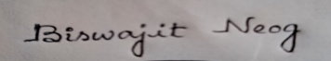
Date:- 01-05-2026

